Name: Date:
NOTES – keep and put in your binder!
NOTES - Biotic and Abotic Factors
Everything in the world can be classified as either:

Now it’s your turn: List the biotic and abiotic factors in this underwater ecosystem.
Word Bank
Fish Rock Coral
Seaweed Water

Biotic factors
Abiotic factors
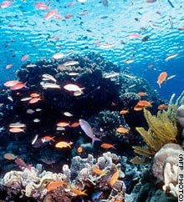

Name: Date:
EXIT TICKET – turn in on your way out!
EXIT TICKET– Biotic and Abotic Factors
- What is an abiotic factor?
___________________________________________________________________________
- What is a biotic factor?
___________________________________________________________________________

List the abiotic and biotic factors in the following image.
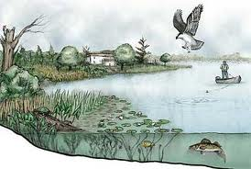

Abiotic Factors | Biotic Factors

