Name: ____________________________ Date: _________________
Sexual vs. Asexual Reproduction Essay

Writing Prompt
Compare and contrast sexual and asexual reproduction. Which reproduction strategy offers the best chance for a species to survive?

Graphic Organizer
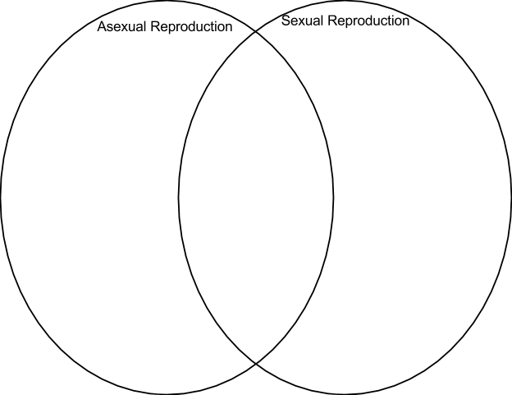
Evidence
In the boxes below (and onto the next side), write evidence that you find from the textbook (asexual reproduction = pages 102-104, sexual reproduction = pages 106-107, 111, 117), your Sciencesaurus handout, and the internet resources listed on witsilscience.weebly.com.

Asexual Reproduction Advantages (continued on next side):
Source | Quote/Evidence

Evidence: Asexual Reproduction Disadvantages
Source | Quote/Evidence

Evidence: Sexual Reproduction Advantages
Source | Quote/Evidence

Evidence: Sexual Reproduction Disadvantages

Source | Quote/Evidence

